RESTful API

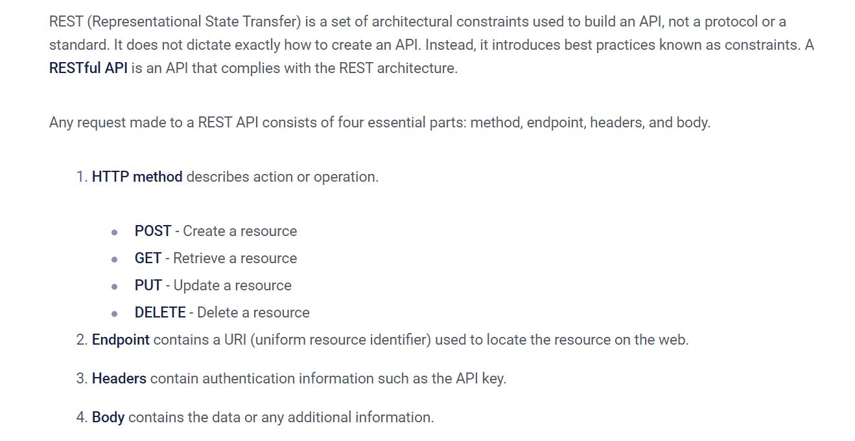

HTTP Request Method : Get Post Put Patch Delete